**1. Matrix effect Sequence - 23 Math for Game Developers - Prop Positioning (TRS Matrices)**

number 1:Scaling

number 2:Rotation

number 3:Translation

But take it to equation, it become: Translation * Rotation * Scaling * V

Because the one nearest to the v will first make effect.

**2. inverse matrix - 24-25 Updated Bullet Collisions (Coordinate Systems)**

Inverse matrx can do the revert operation of a matrix

make intersection between no-algin AABB and a line, you can transform line to the local coordinate system of AABB

These tutorial also teach you how to get inverse matrix

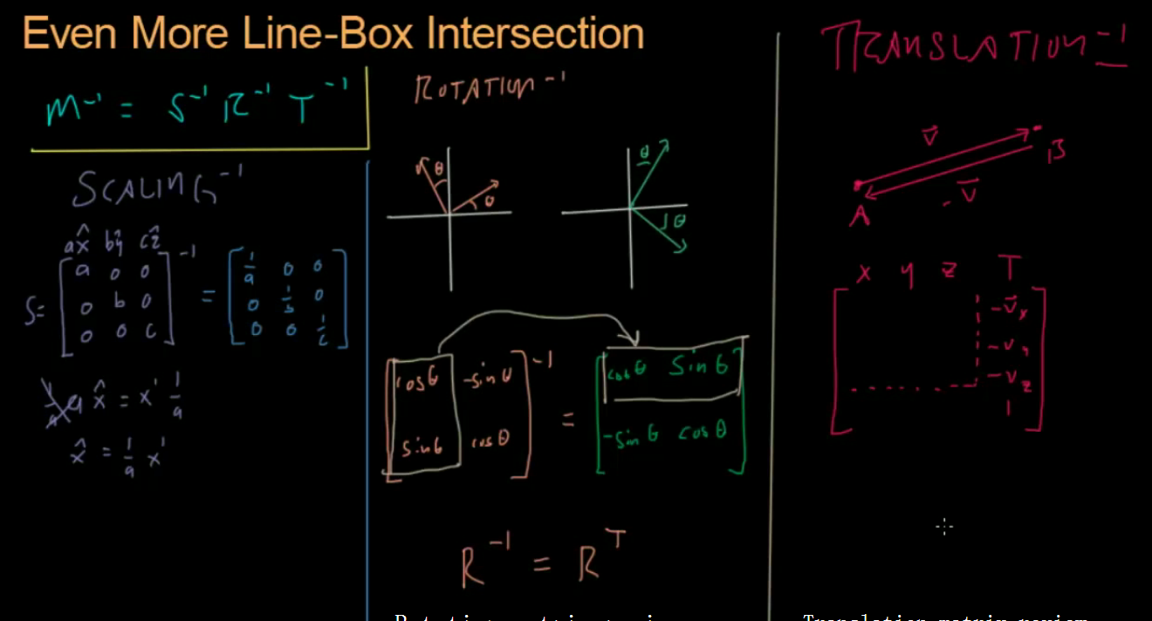

3. View Frustum Cull - Math for Game Developers - Frustum Culling

Jude by the side of 6 plane.

